Megan Wheeler

CSD 325

Assignment 1.2

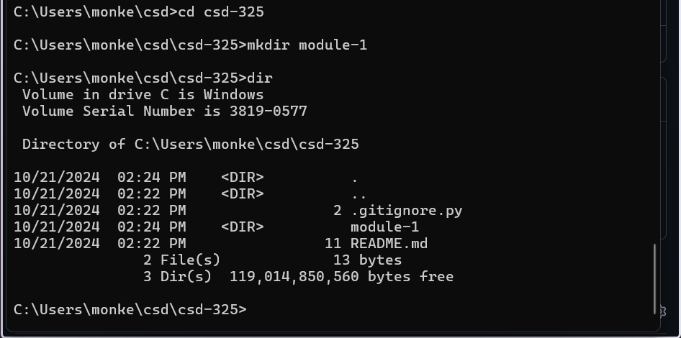

https://github.com/Pandma13/csd-325/tree/026df36fe1a77162ebd96802dc04ea8f21eb2f83/module-1